Team: **GOD** (Granter of Data)

*Sohal Patel, Gabriel Harper, Jenna Bennet, Julia Anderson and Lucas Weaver*

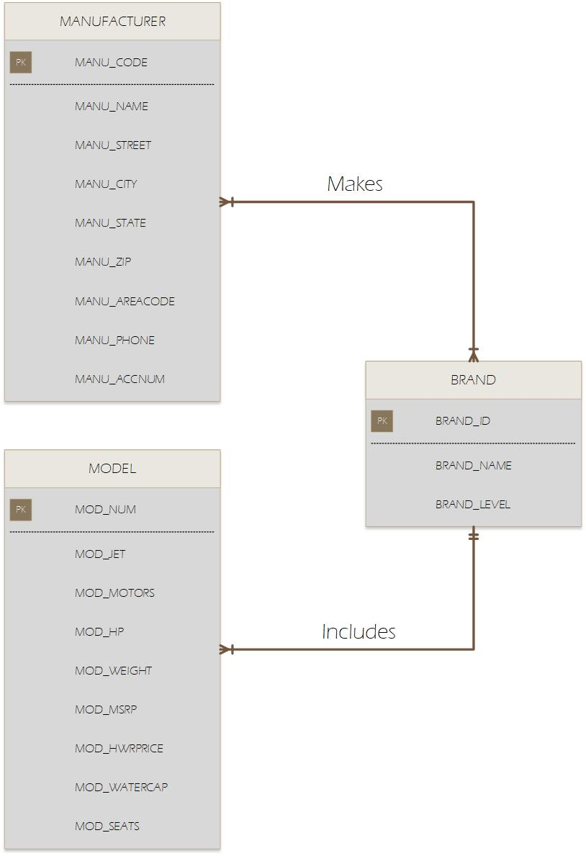2.

4. The attributes with the Private keys are not necessary but just to show how it connects if it had attributes

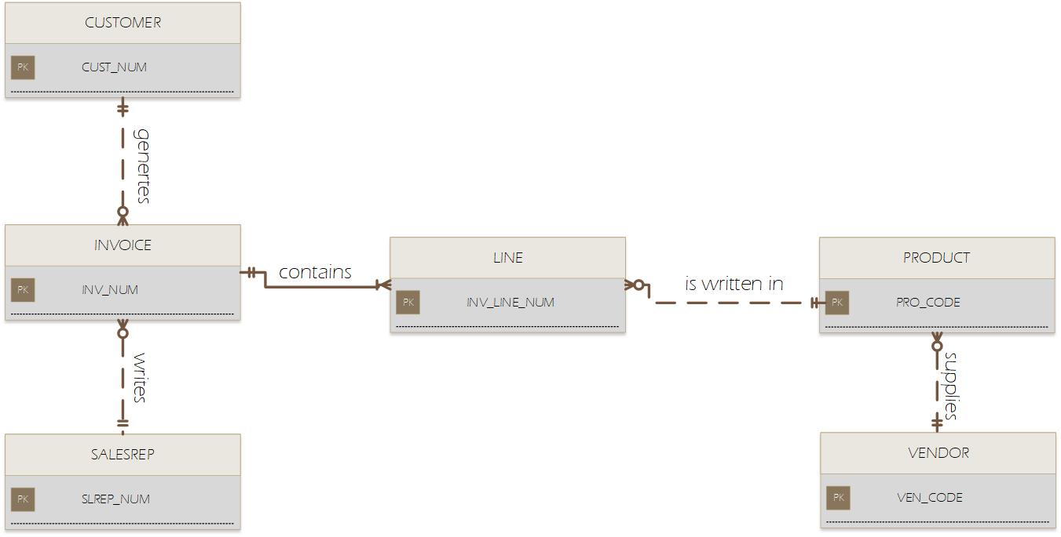

5.

|  |  |  |  |
| --- | --- | --- | --- |
| ENTITY | RELATIONSHIP | CONNECTIVITY | ENTITY |
| INSTRUCTOR | teaches | 1:M | CLASS |
| COURSE | generates | 1:M | CLASS |
| CLASS | is listed in | 1:M | ENROLL |
| TRAINEE | is written in | 1:M | ENROLL |

* A few instructors may show a class each other period or even occasionally. Along these lines, it is sensible to accept that CLASS is discretionary to INSTRUCTOR during an enrollment period. This flexibility bodes well from an execution point of view, as well. For instance, on the off chance that you appoint another instructor, that instructor won't yet have shown a class.
* A COURSE doesn't really create a class during each training period.
* Each CLASS must be identified with a COURSE.
* Subsequently, if ENROLL is discretionary with TRAINEE is reasonable. Most trainees are likely to be registered in courses over a certain span of time but, many trainees are likely to get jobs without going to a class.
* You can't make an enrollment record without having a trainee. Consequently, TRAINEE is mandatory to ENROLL.